**Group_11**

**Imdb_Final_Project**

**Average Rating Movie Title:**

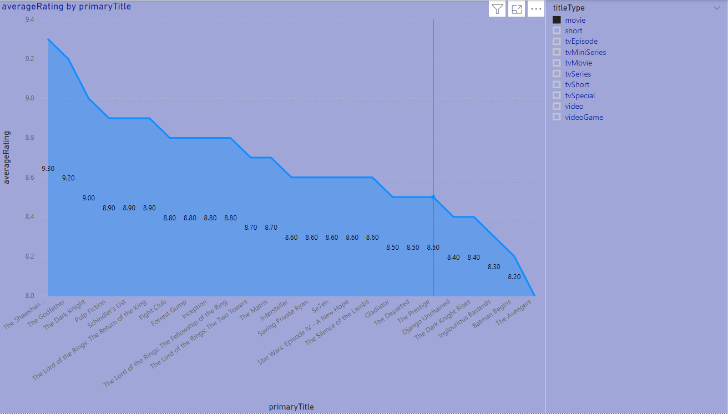

**Movie Titles based on Number of Votes:**

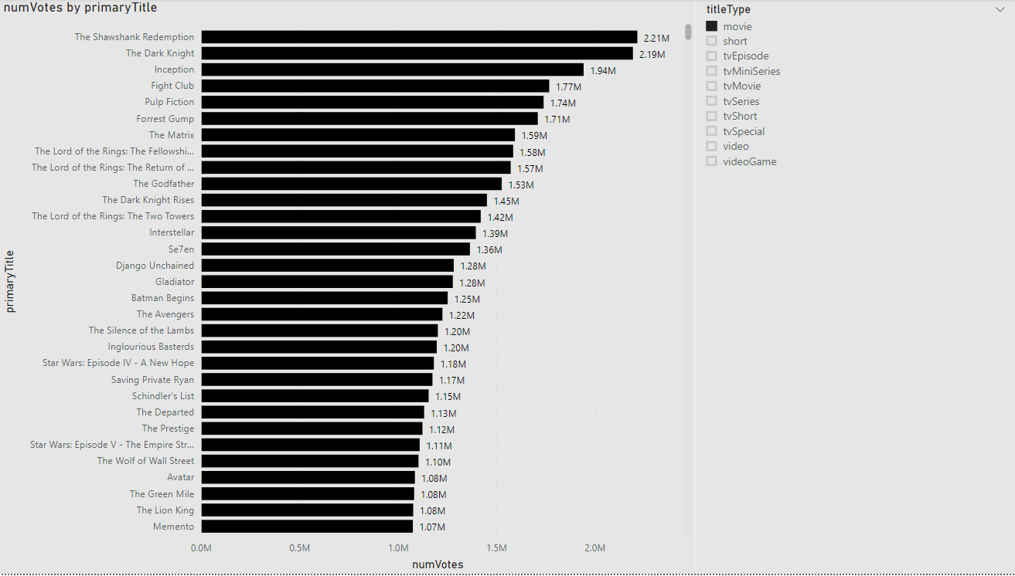

**Movie Title Based on Rating:**

